* Chapter 8 is very very important

(concept wise for virtual interpreter setup)

* Chapter 23 is very very important

(inheritance in case if it is not default constructor)

Read, readline, readlines 🡪 difference (readlines will store in a list)

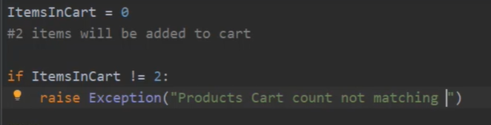

Driver.minimize_window (): to minimize the window.

* chapter 40 is important (class)

(if multiple classes are there, then we need to select any one of those)

In chapter 43 you will get multiple websites for practice.

# from selenium.webdriver.support.select import Select

* **chapter 47 is import (Auto suggestive locators)**
* chapter 56 is important (explicit wait)
* **chapter 62 is very very important (table reading)**
* link_text will be applied only when anchor tag is there.

# from selenium.webdriver import ActionChains

# java script is must needed for scroll operations

# ChromeOptions

* chapter 70 is good (chrome options)
* **chapter 71 is important (xpath selection)**
* **chapter 72 is important (xpath selection continues)**

Skipping these three for now.

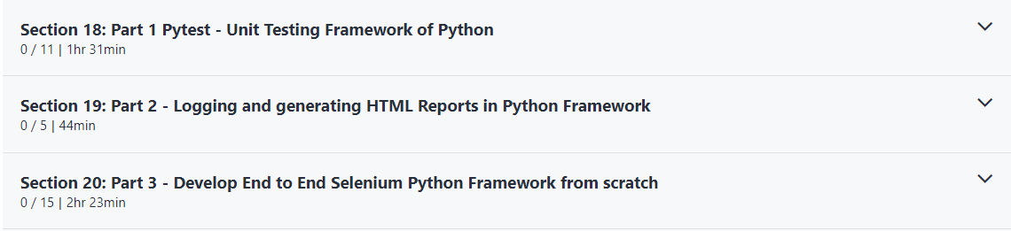

* Chapter 108 (Jenkins setup- just for reference)
* **Chapter 109 is important (Create job for Jenkins**
* **Chapter 110 is important (Dynamic browser setup in Jenkins)**
* Chapter 111 (Jenkins XML Reporting)

Skipped for now:



* Git config commands:

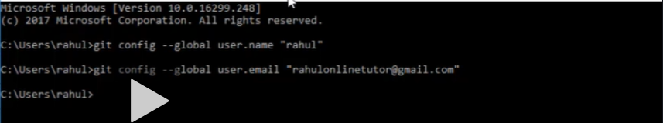

* **Chapter 127 is important (Git branching)**

# git checkout -b develop (to create a new branch)

# git branch (to know current branch)

# git push origin master

# git pull origin master

# git checkout develop (to switch a project)

# git merge develop (to merge develop branch to your active branch)- pls switch to master branch and pull the latest code before doing it

* Chapter 128 is important (how to resolve merge conflict)